**1.Project Description :**

Internet of things system is a rapidly expanding idea in this era of industrialization technology meanwhile. It has become important for many manufacturing companies and other industries care about employees health, safety and other side effects. The internet of things that can monitor the physical objects that are connected to the Internet (wireless networks) and can be controlled from anywhere in the world. Environment issues may cause big disaster these days. One of the huge issues faced are Air pollution and sound pollution. By finding and detecting air pollution levels is the main objective

Air pollution is the biggest problem of every nation, whether it is developed or developing. Many times the emission of gases affects both the human beings and animals are affected by lung cancer, irritation of eye, breathing. Some other harmful effects caused by pollution are mild allergic reactions near throat, eyes and nose as well as some serious problems like bronchitis, heart diseases, pneumonia, lung and aggravated asthma. These are the problems that usually occurs while the industry does not take proper steps to reduce the gases as per government rules. Health problems have been growing at faster rate especially in urban areas of developing countries where industrialization and growing number of vehicles leads to release of lot of gaseous pollutants.

**2.Implementation:**

Ground are not included, etc.), which are specifically aimed at decreasing the amount of information required from the user. The process of air pollution modeling includes the four stages (data input, dispersion calculations, deriving concentrations, and analysis), as we can see in Figure 1. The accuracy and uncertainty of each stage must be known and evaluated to ensure a reliable assessment of the significance of any potential adverse effects. Currently, the most commonly used dispersion models are the Gaussian-plume models. These are based on mathematical approximation of plume behavior and are the easiest models to use.

Concerning the atmospheric pollution, the major environmental issues in the Bor area include annual emissions to the atmosphere of up to 250000 tonnes of sulphur dioxide and up to 1300 tonnes of particulate contaminated with heavy metals. The weather is monitored using a conventional mechanical system and traditional measurements of humidity, temperature, rainfall and maximum/minimum temperatures. Wind speed and direction indicate environmental risk areas affected by major pollution sources. From the obtained meteorological data, the prevailed winds were found to be predominantly from west - northwest and therefore tend to carry the pollution away from the main centers of population. During the rainy periods, the typical east or southeast winds are of more concern. Light and variable winds are likely to cause very highly-localized concentrations of vapors. Inversions may also o

**3.Circuit Diagram** :

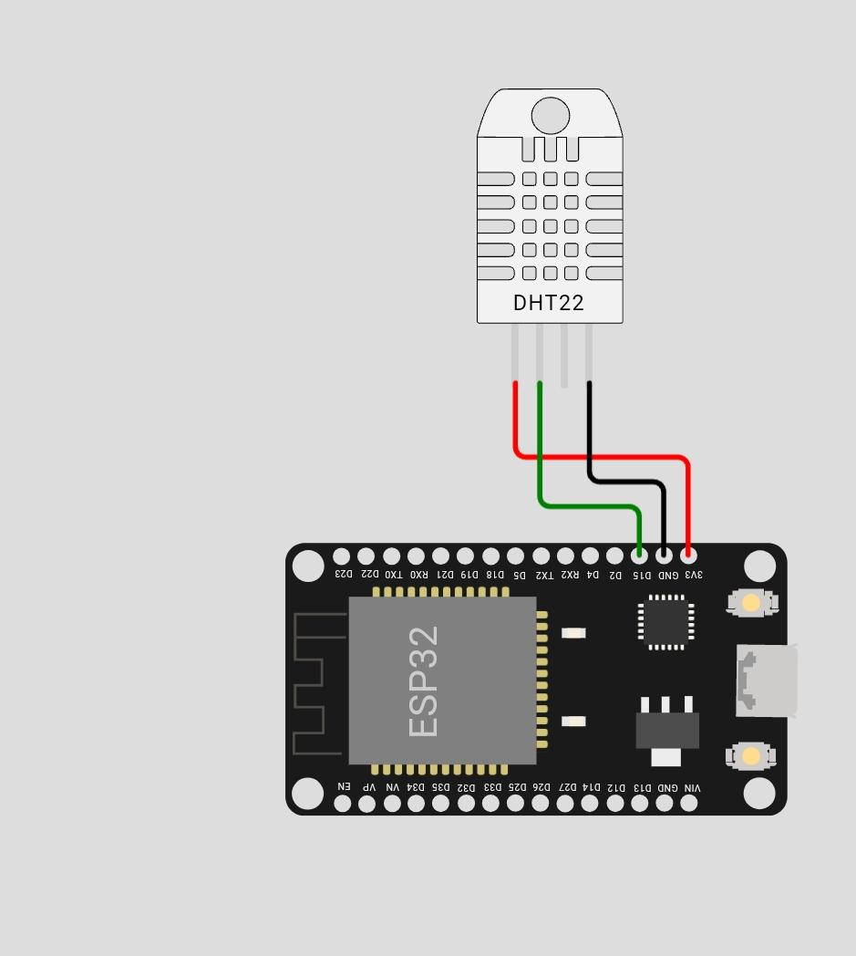

**4.Source Code:**

* **Front End**;

from machine import Pin

from time import sleep

import dht

import network

sta_if = network.WLAN(network.STA_IF)

if not sta_if.isconnected():

print('connecting to network...')

sta_if.active(True)

sta_if.connect('Wokwi-GUEST', "")

while not sta_if.isconnected():

pass

print('network config:', sta_if.ifconfig())

sensor = dht.DHT22(Pin(15))

while True:

try:

sleep(2)

sensor.measure()

temp = sensor.temperature()

hum = sensor.humidity()

temp_f = temp * (9/5) + 32.0

print('Temperature: %3.1f C' %temp)

print('Temperature: %3.1f F' %temp_f)

print('Humidity: %3.1f %%' %hum)

except OSError as e:

print('Failed to read sensor.')

* **Back End;**

{

"version": 1,

"author": "B. Mohan",

"editor": "wokwi",

"parts": [

{

"type": "wokwi-esp32-devkit-v1",

"id": "esp",

"top": 31.9,

"left": 139.6,

"rotate": 270,

"attrs": { "env": "micropython-20231005-v1.21.0" }

},

{ "type": "wokwi-dht22", "id": "dht1", "top": -95.7, "left": 167.4, "attrs": {} }

],

"connections": [

[ "esp:TX0", "$serialMonitor:RX", "", [] ],

[ "esp:RX0", "$serialMonitor:TX", "", [] ],

[ "dht1:VCC", "esp:3V3", "red", [ "v28.8", "h67.2" ] ],

[ "dht1:GND", "esp:GND.1", "black", [ "v38.4", "h28.8" ] ],

[ "dht1:SDA", "esp:D15", "green", [ "v48", "h38.5" ] ]

],

"dependencies": {}

}

**Sample output;**

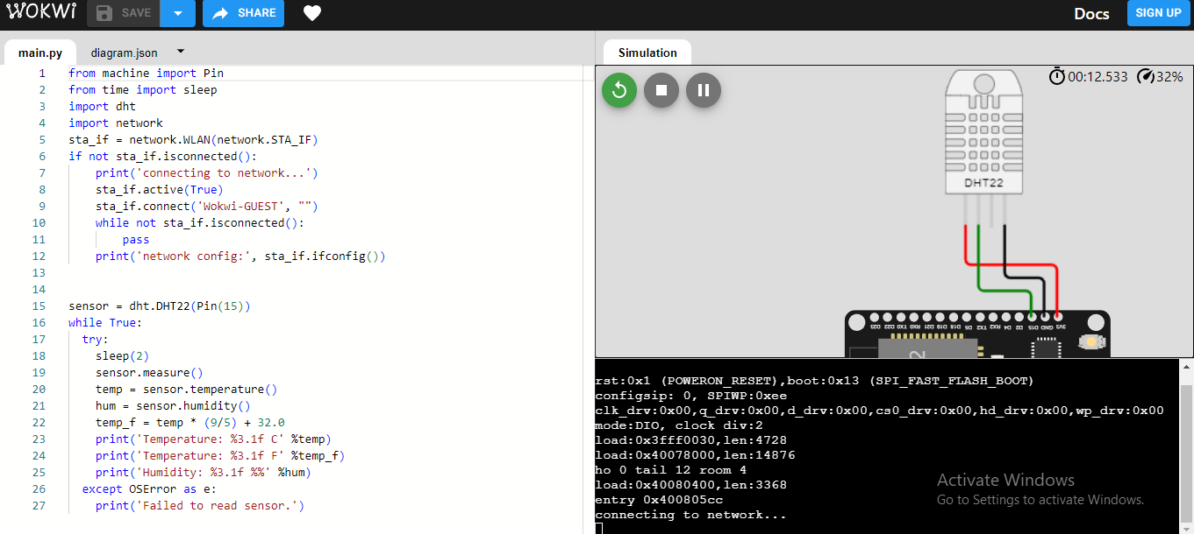

**Fig 4.1.1: component name: DHT22**

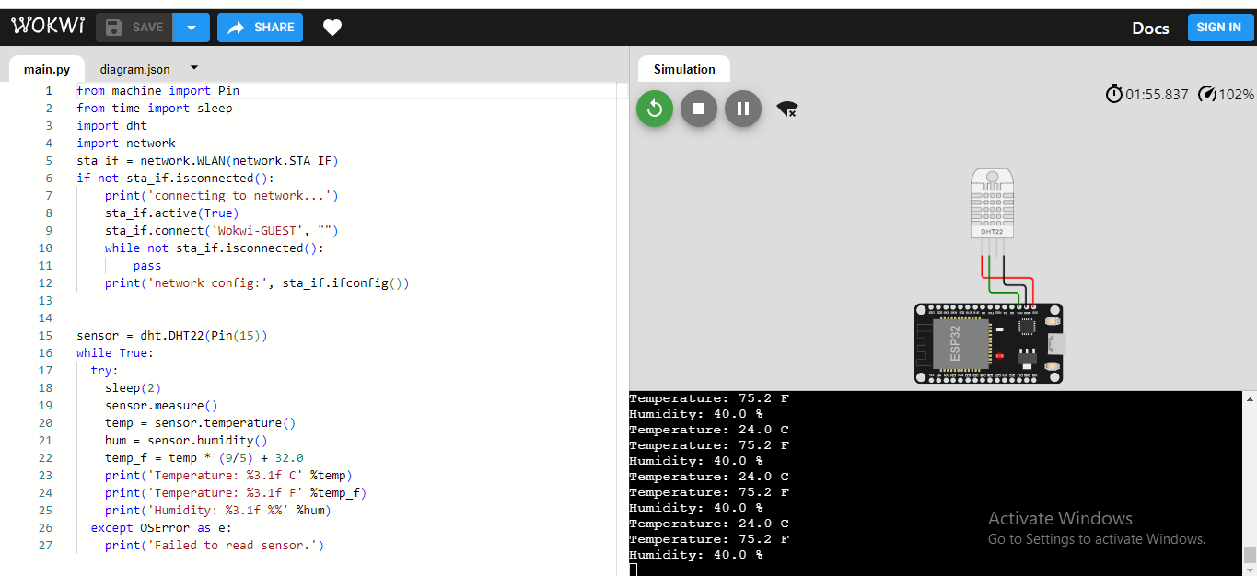

**Fig 4.1.2:Component name: ARDUINO**

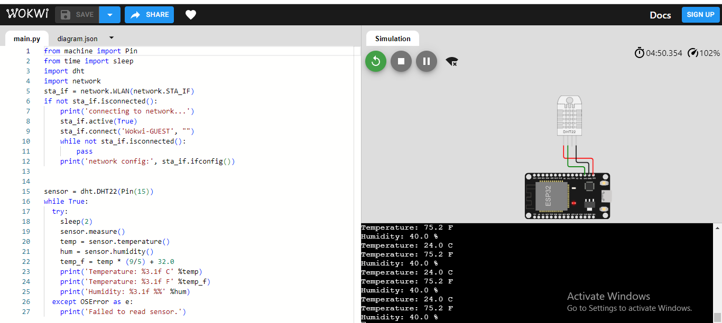

**Fig 4.1.3:Needed components placed in arduino software**

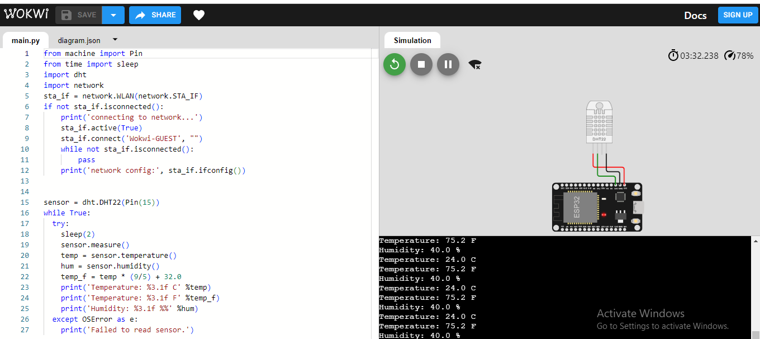

**Fig 4.2.1:connected negative pin to the ground**

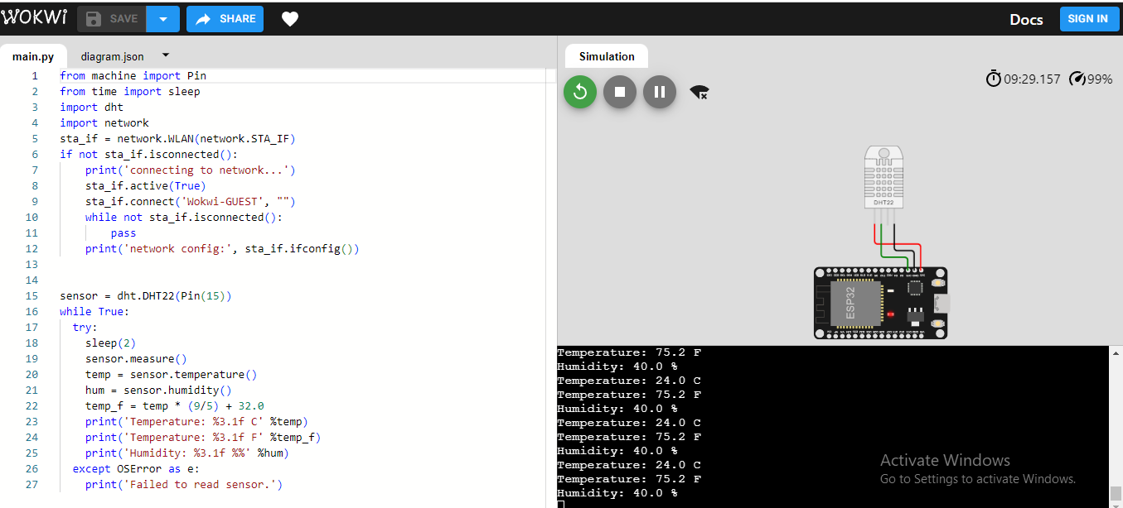

**Fig 4.2.2:sensor 2nd pin connected to arduino’s D15**

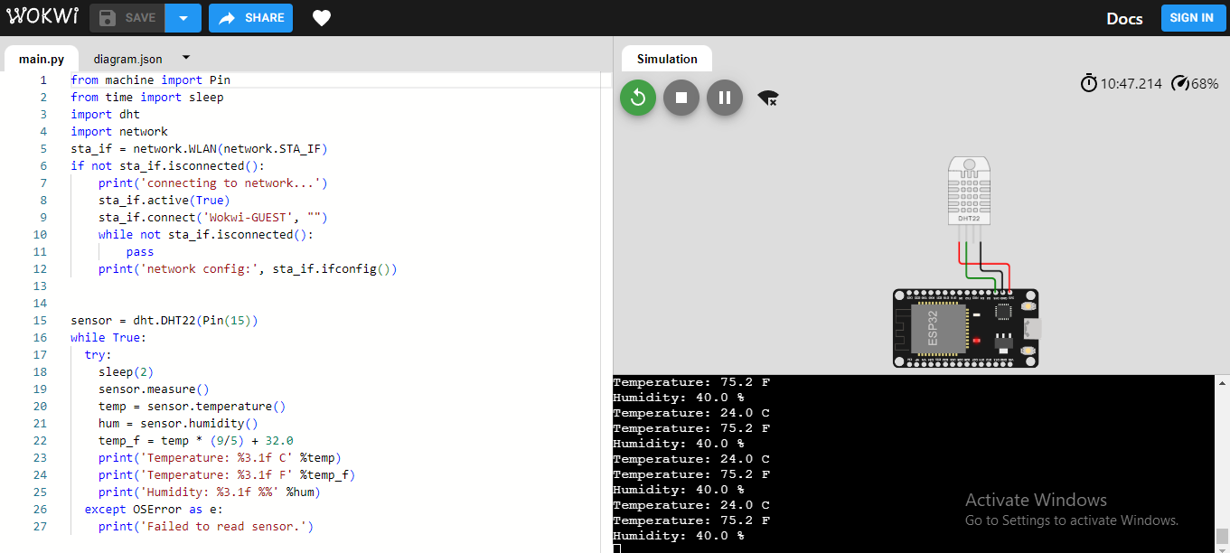

**Fig4.2.3: sensor positive pin connected to vin**